**Dataset description**

Data Acquisition Parameters:

* Device: MEGIN Triux Scanner
* Channel: 306 MEG channels (102 Magnetometer; 204 Gradiometer)
* Sampling Frequency: 1000Hz

Temporal Filter: 0.5 to 100Hz

Artifact Correction: Z – score based automatic artifact rejection using MATLAB Fieldtrip toolbox.

## Interleaved Eyes Open and Eyes Closed condition

In this session we collect resting state data by alternating epochs of eyes closed with eyes open to guarantee a good reactivity of the alpha rhythm (Klimesch, 1999; Hsiao *et al.*, 2014; Miraglia *et al.*, 2016). The subjects will hear explicitly the voice command “Open” and “Close” to indicate switching between eyes open/closed conditions, respectively (Figure 1). During both conditions, subjects should remain relaxed and, particularly, during eyes open should fixate at a cross at the centre of screen while minimizing eyes blinking. The duration of each interleaved condition or inter-trial interval (ITI) is varied randomly between 12 and 18 seconds to avoid habituation. Total experiment duration equals to 8 minutes, allowing 16 trials per condition (Total=32 trials) or about 200 seconds after discarding the first 2 seconds with respect to the trigger for the switching command in each trial, in order to minimise switching side effects and blinking artefacts.

## Auditory sensory gating to measure attention

The evoked field P50 response is used to test inhibitory gating deficit as this response is known to undergo cholinergic modulation. Alzheimer’s patients commonly use acetylcholinesterase inhibitors which improve disease symptoms by enhancing cholinergic signalling. Although attention domain is less affected in the earlier stages, related executive control and inhibition can be impaired (Thomas *et al.*, 2010). The P50 component is studied using an auditory sensory gating paradigm consisting of paired clicks (duration=40 ms, ISI=500 ms, ITI=4-8 sec) presented at 60 dB above hearing threshold, while participants are watching a silent moving or reading to engage their attention. In this experiment, participants are instructed to ignore the auditory stimulation while watching a silent movie (Figure 3). It is recommended that participants abstain from smoking and caffeine at least 12 hours before the MEG session. Total experiment duration equals 8 minutes, allowing 80 trials of paired clicks.

Unprocessed data Trial info:

MCI 1st click:

Subject 26: 45 trials

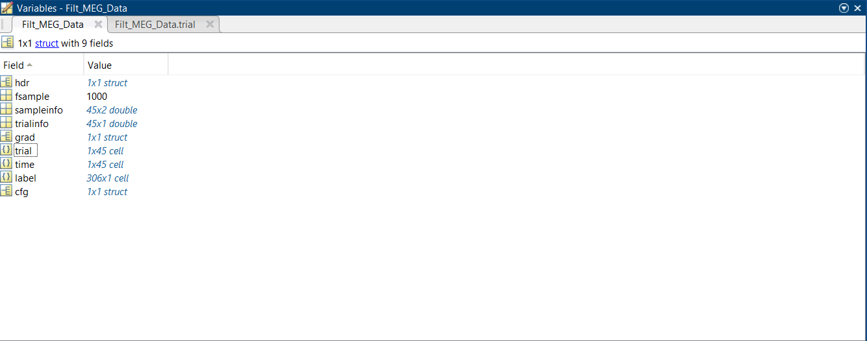

Subject 27 1st click: 34 trials

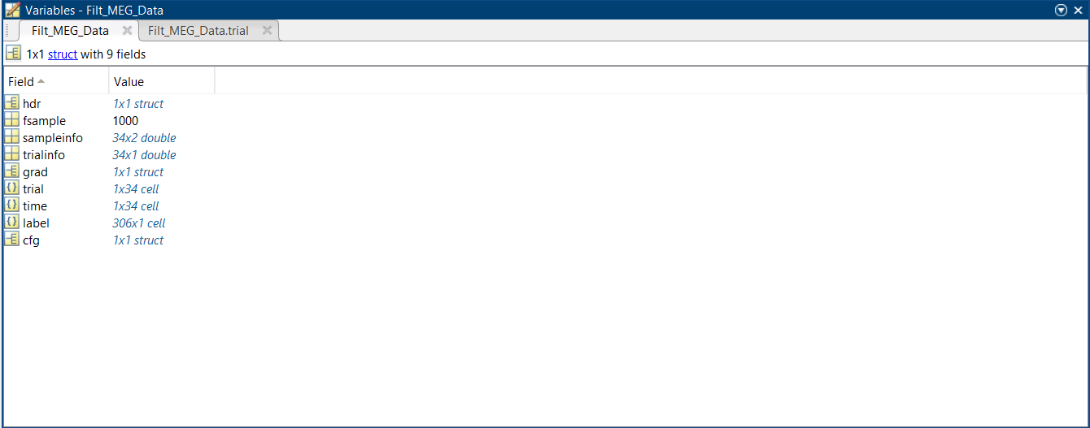

Subject 28 1st click: 39 trials  
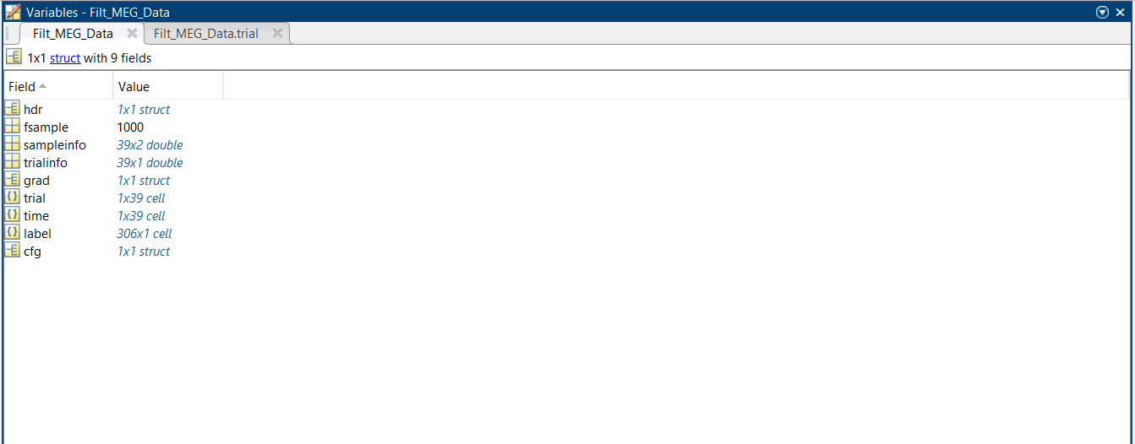

Subject 30 1st click: 44 trials

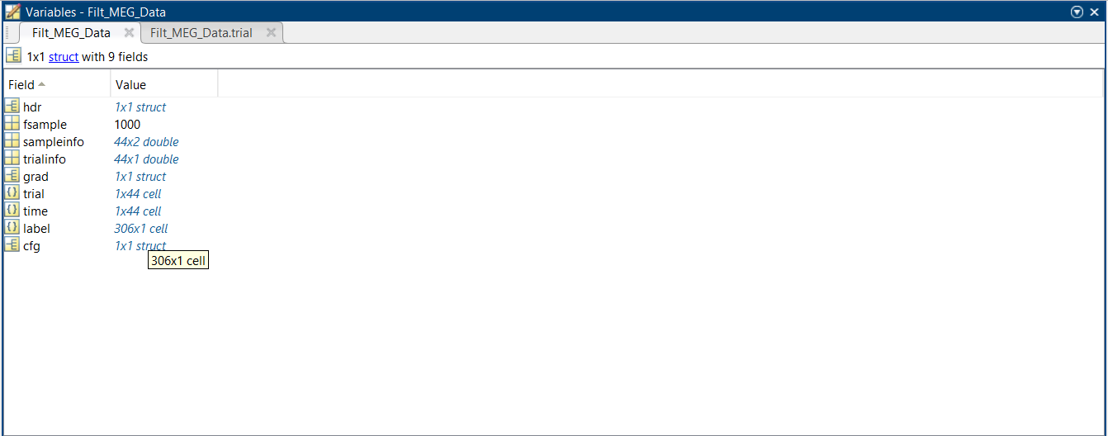

Subject 311st click: 44 trials

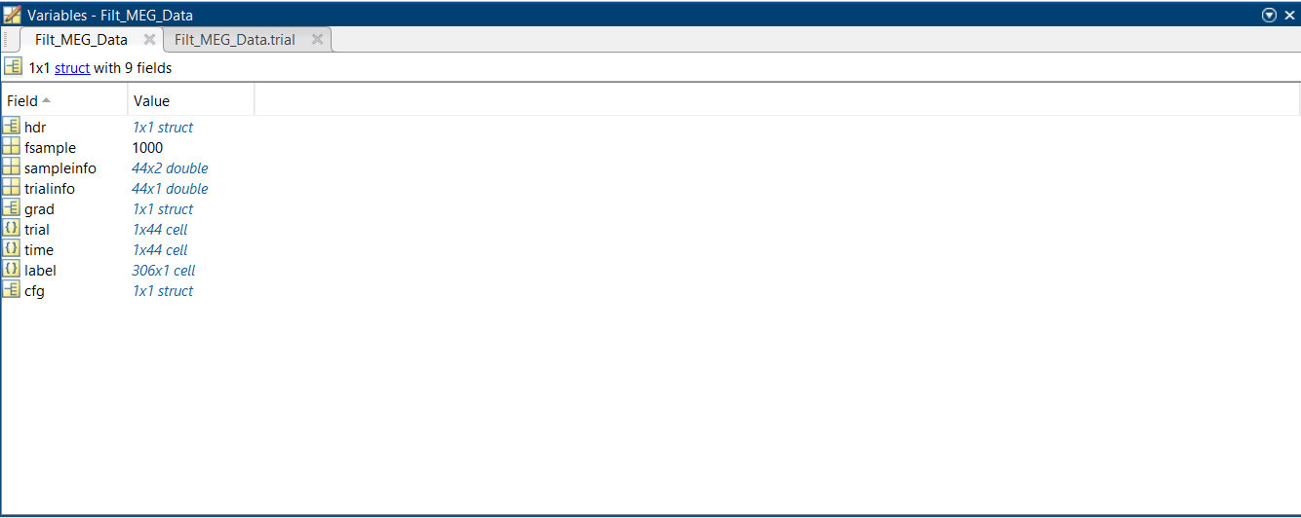

Total: 206 trials

MCI 2nd click data

Subject 26 2nd click: 40 trials

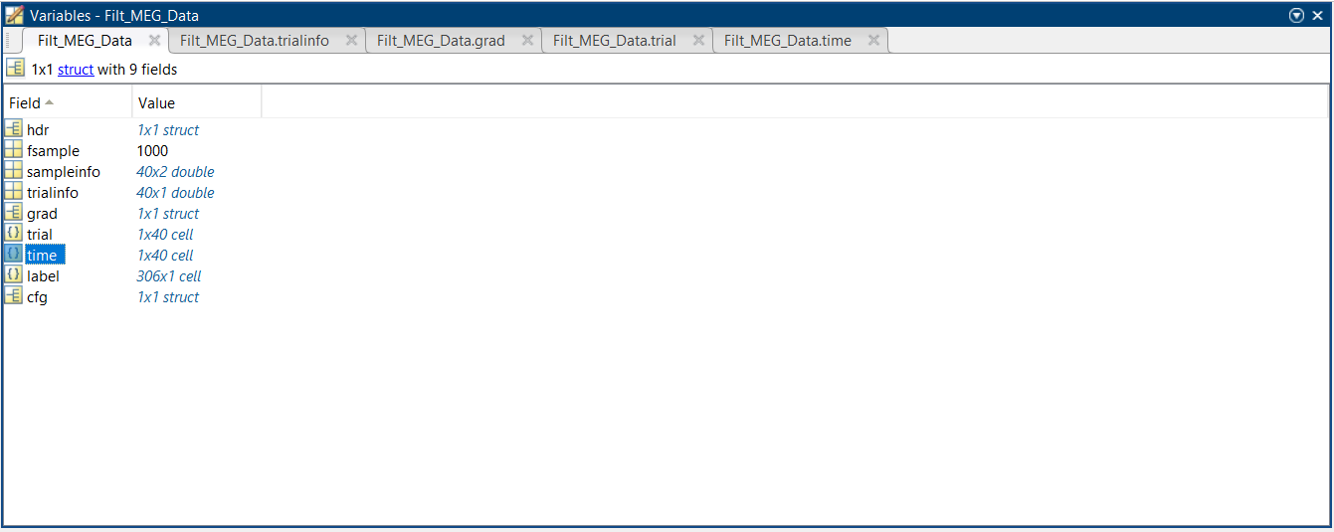

Subject 27 2nd click: 33 trials

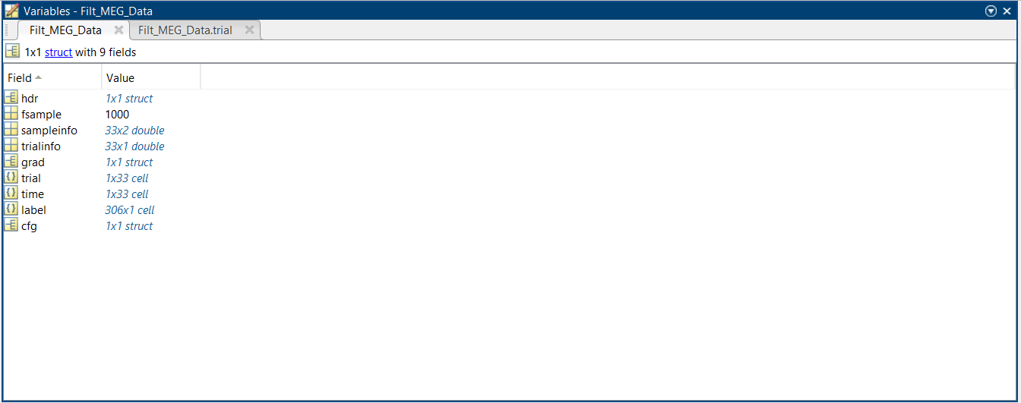

Subject 28 2nd click: 32 trials

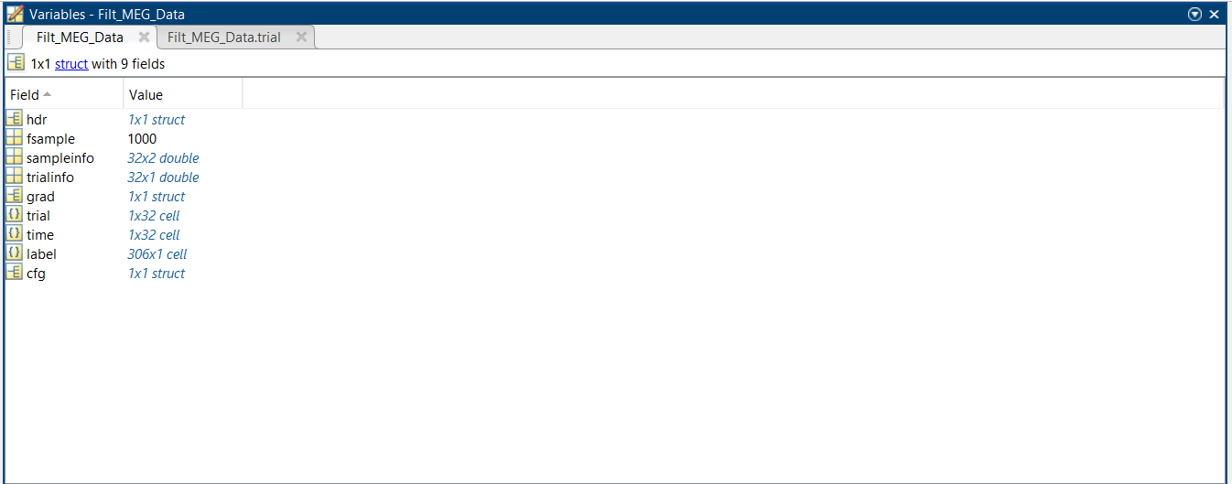

Subject 30 2nd click: 43 trials

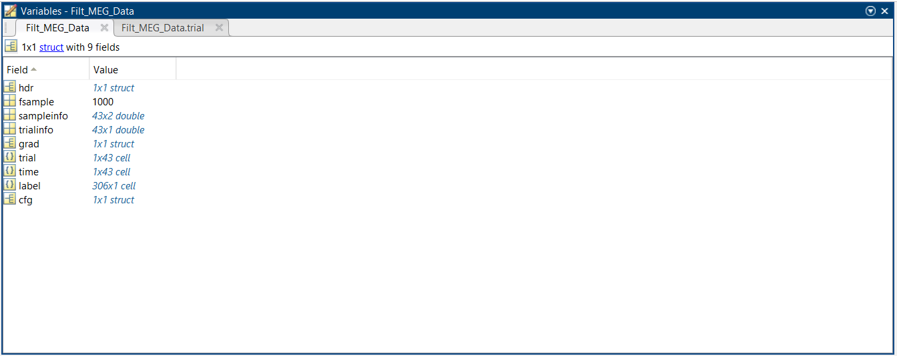

Subject 31 2nd click: 46 trials

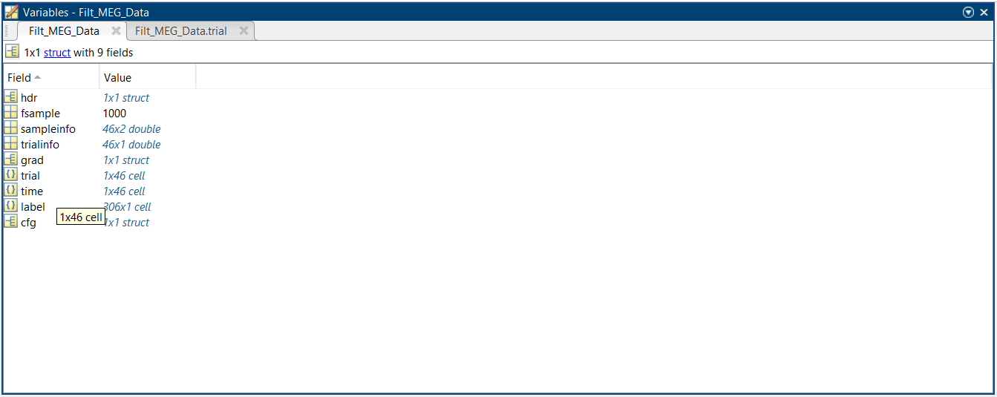

Total : 194 trials

MCI rsec:

Subject 26 rsec: 16 trials

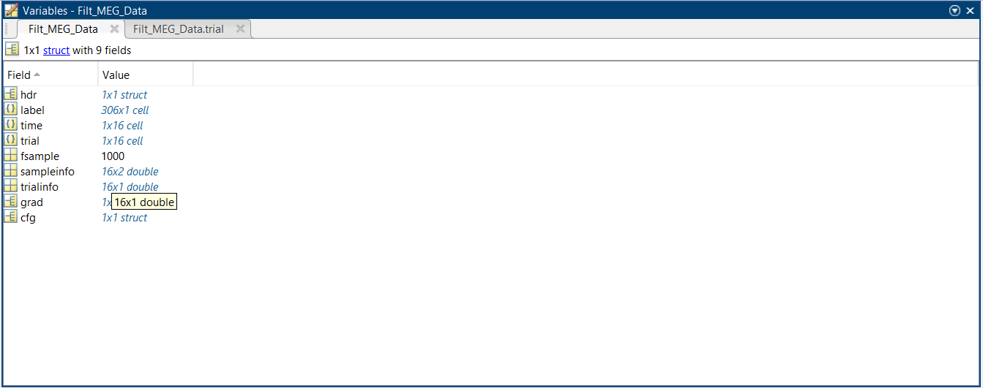

Subject 27 rsec: 16 trials

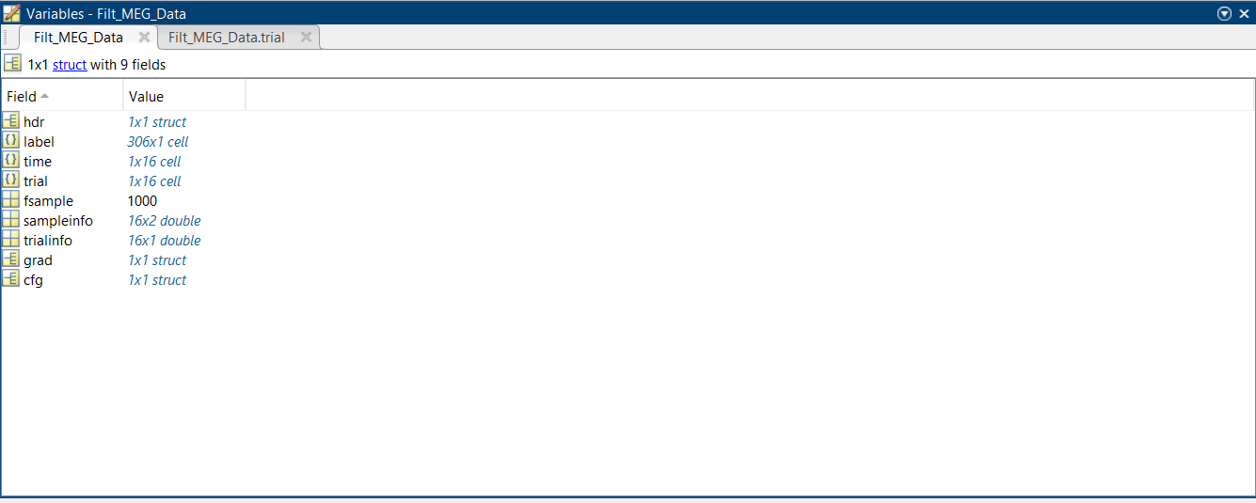

Subject 28 rsec: 16 trials



Subject 30 rsec: 16 trials



Total : 64 trials

MCI rseo:

Subject 26: 15

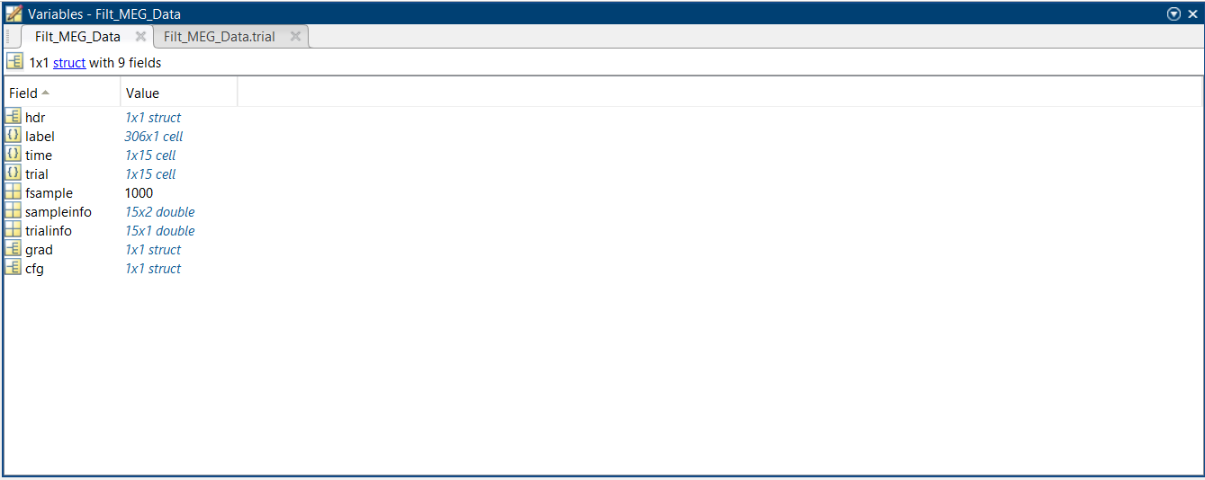

Subject 27: 16

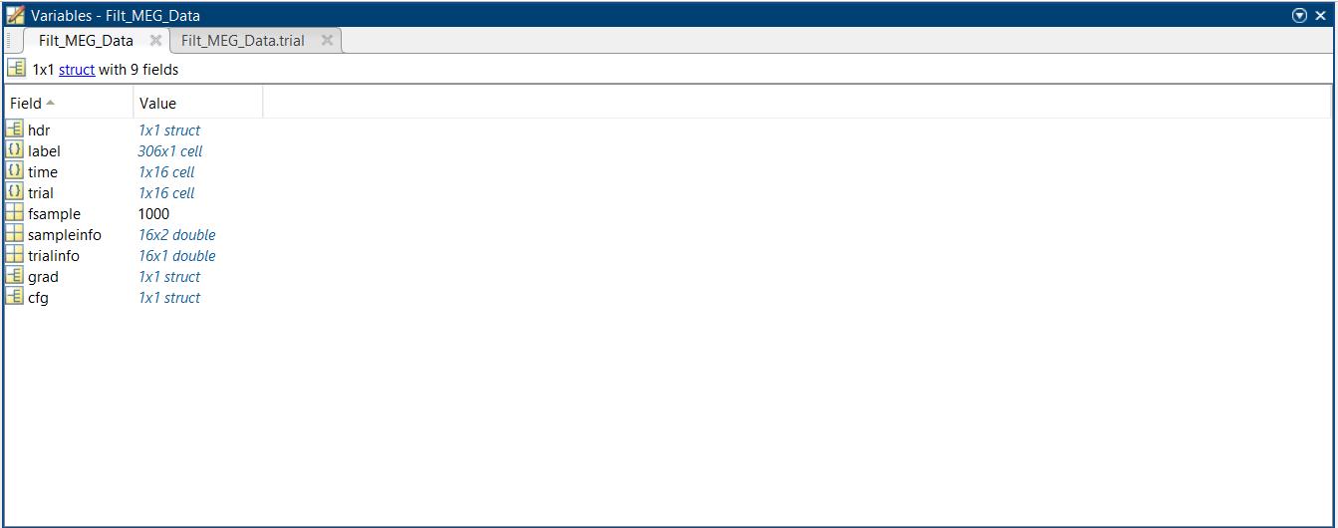

Subject 28: 16



Subject 30 : 16



Subject 31: 16



Total : 79 trials

Healthy 1st click:

Subject 1 1st click: 31

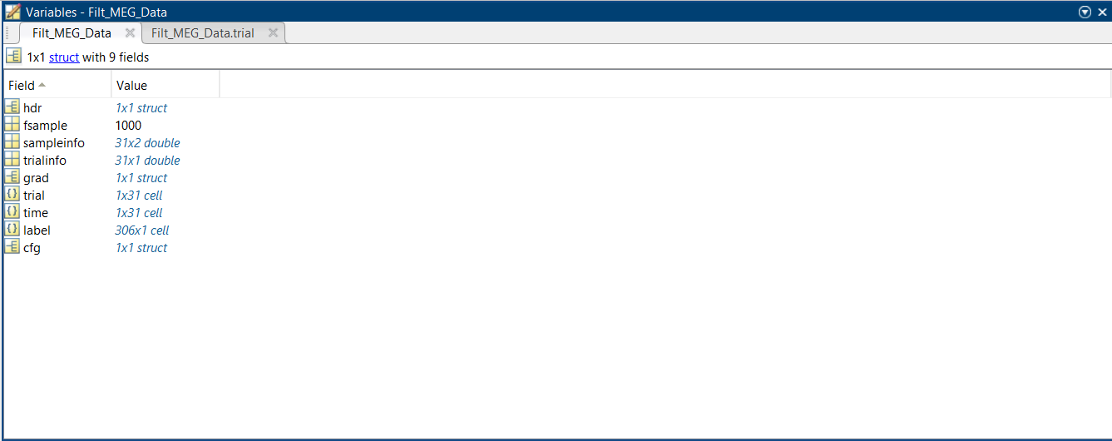

Subject 2 1st click: 61

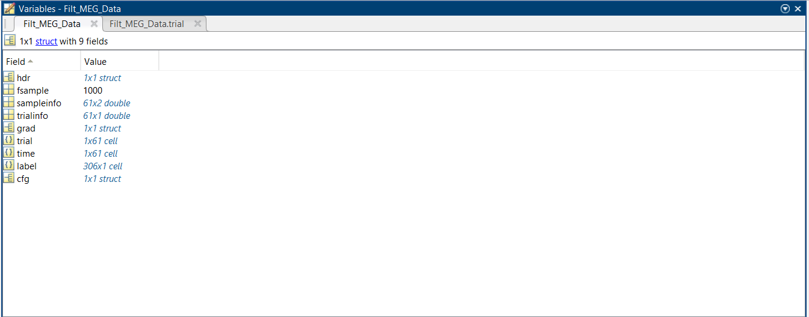

Subject 3: 21

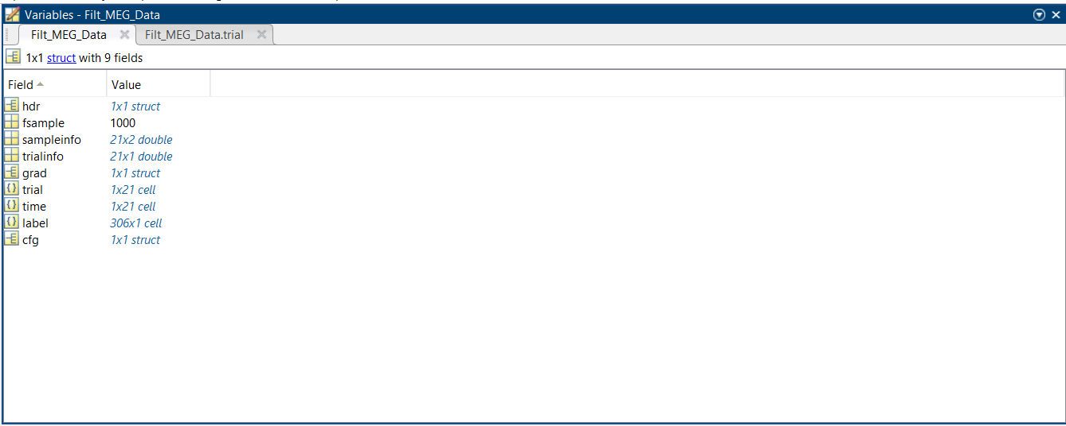

Subject 4: 32

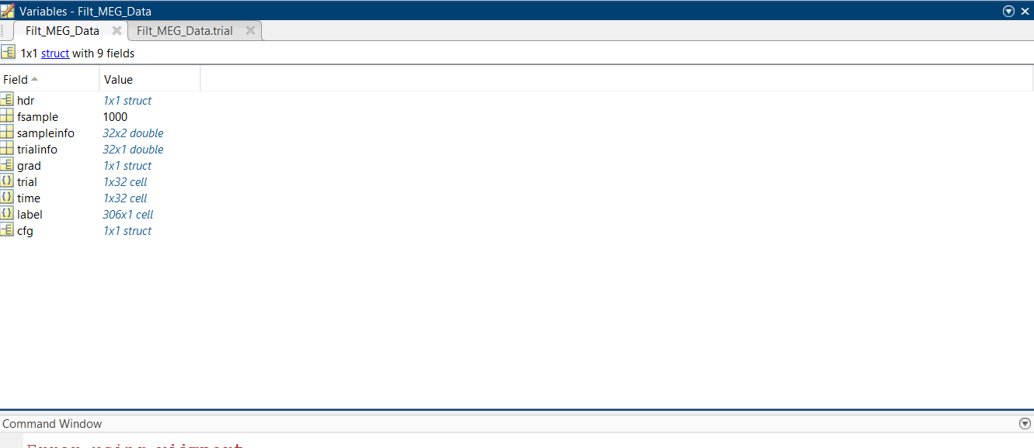

Subject 6: 35

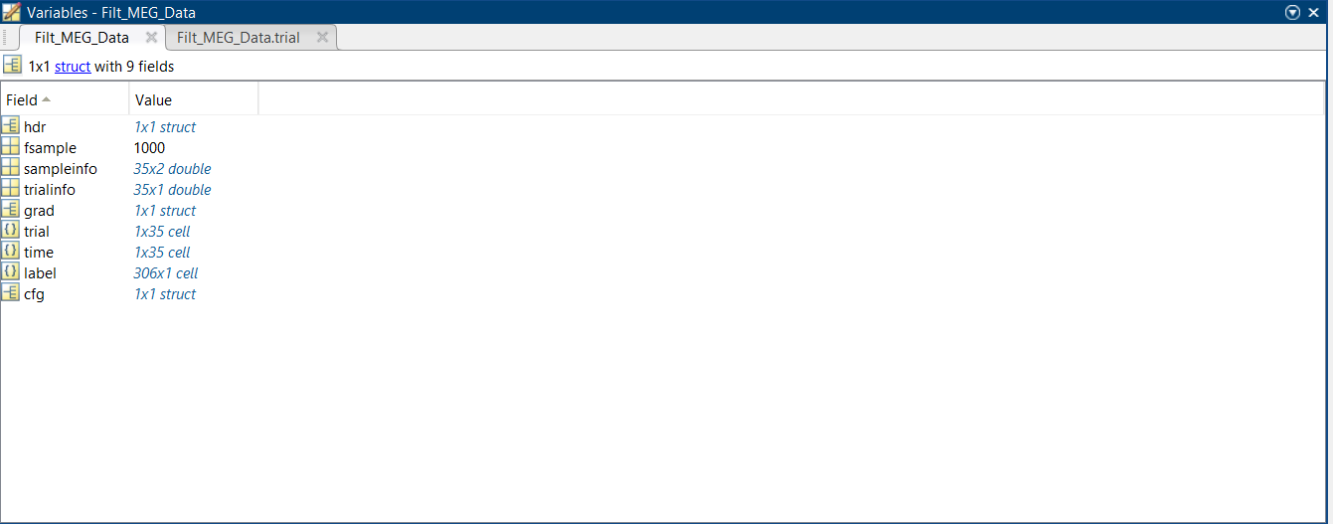

Subject 8: 28

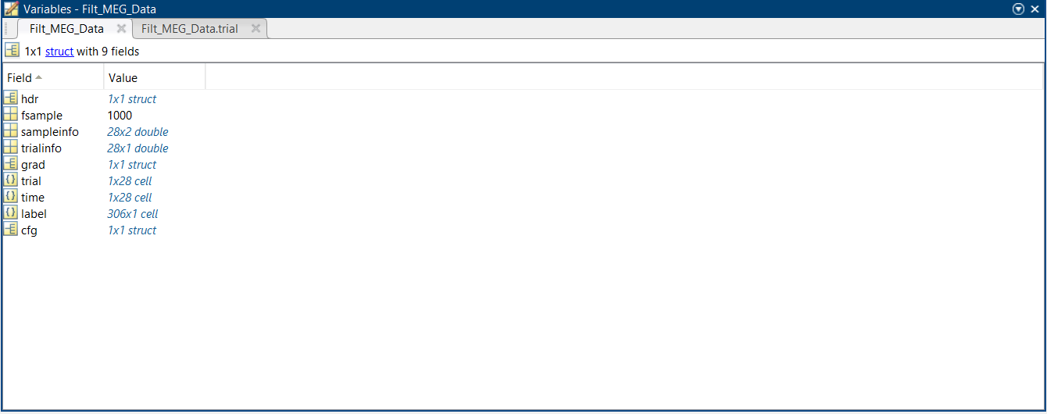

Subject 10: 35

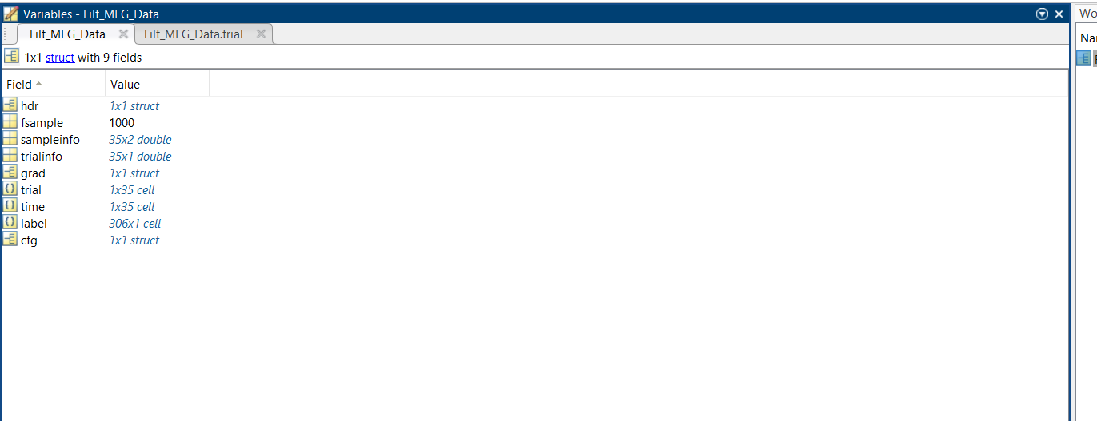

Subject 11: 28

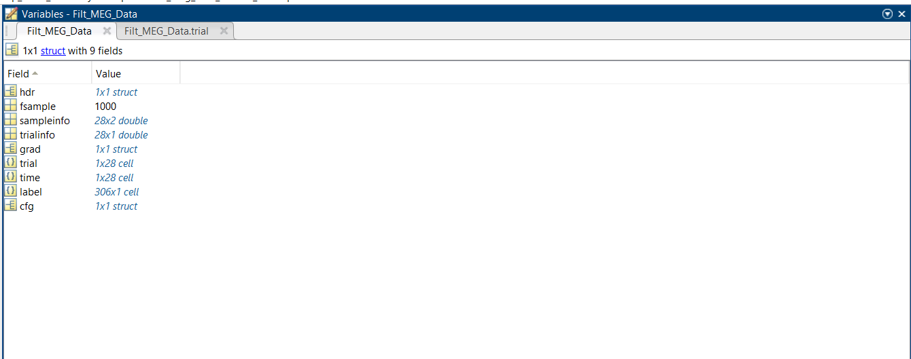

Subject 12: 44

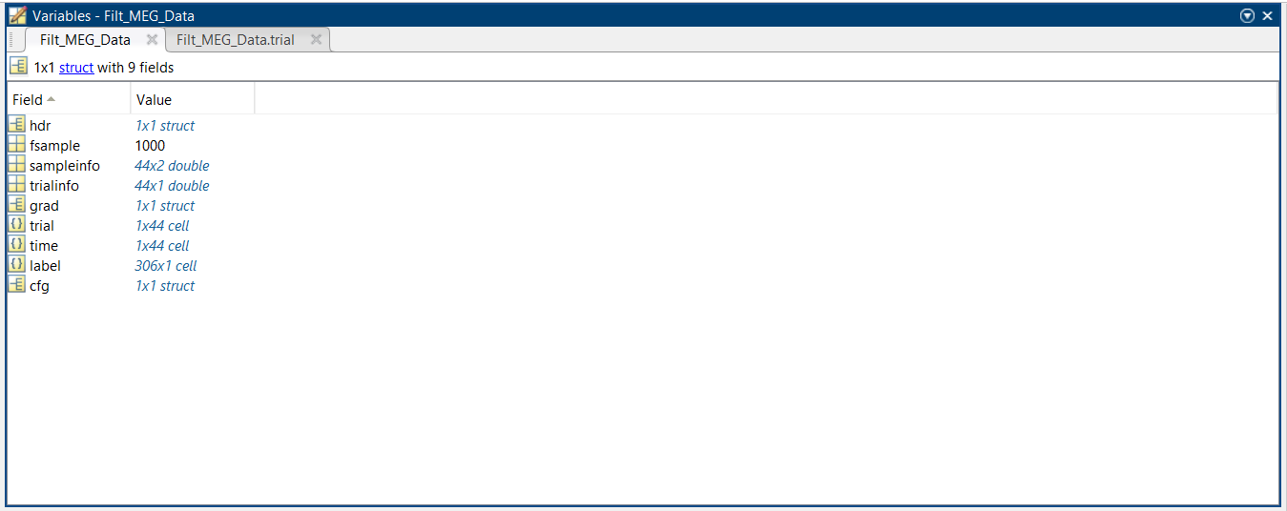

Subject 13: 40

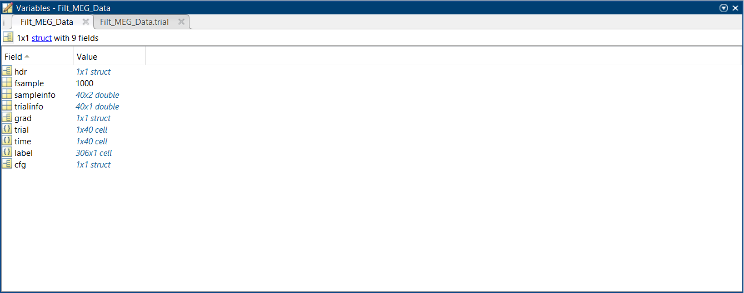

Subject 14: 34

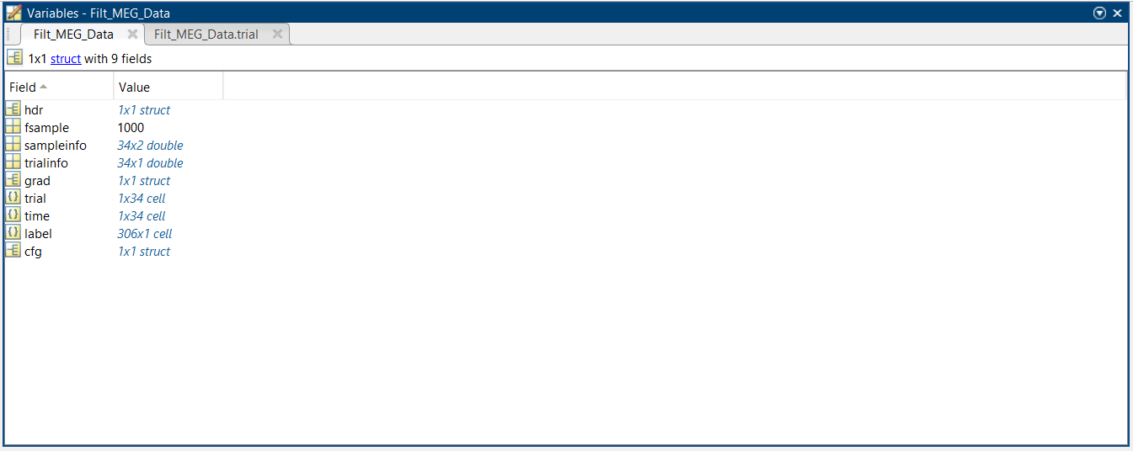

Subject 15: 26

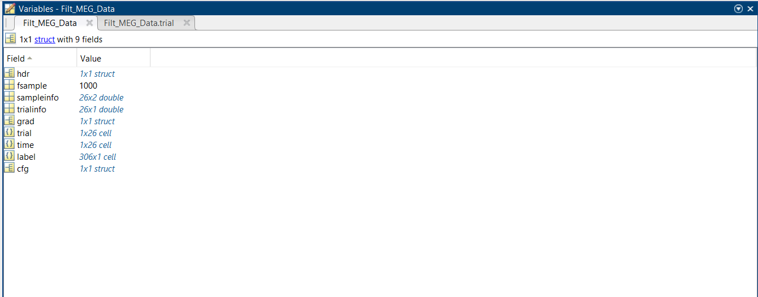

Subject 16:26

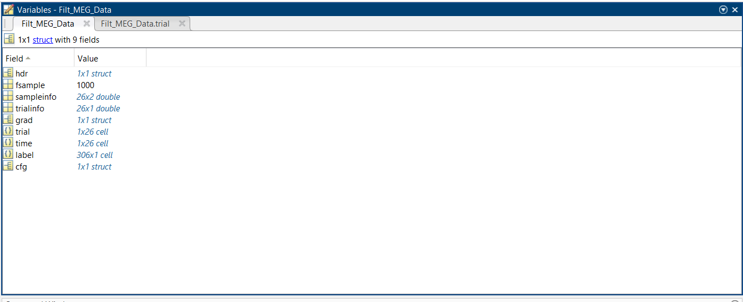

Subject 17: 26

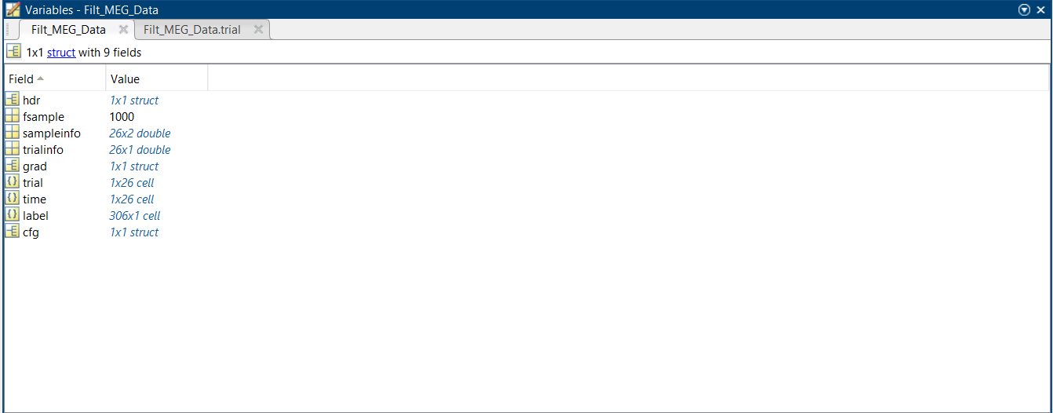

Subject 18: 33

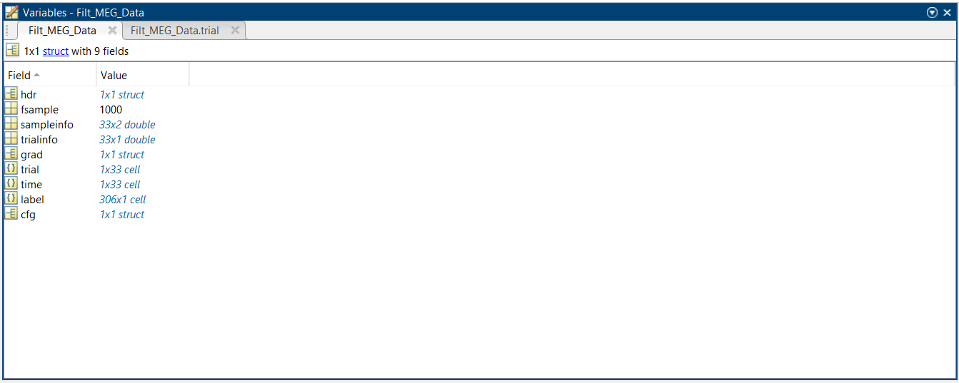

Subject 20: 25

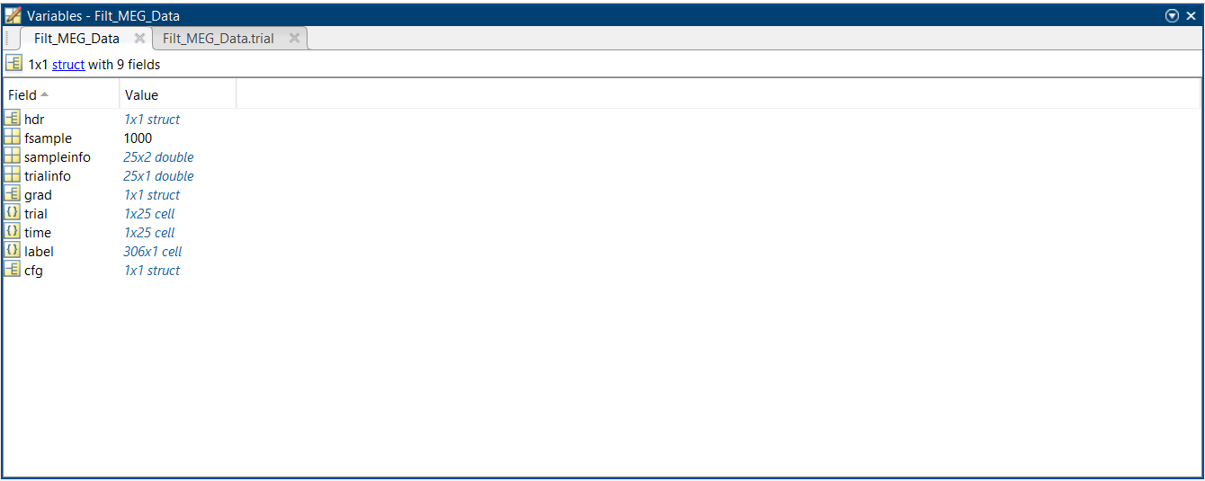

Total: 525

Healthy 2nd click:

Subject 1 :34

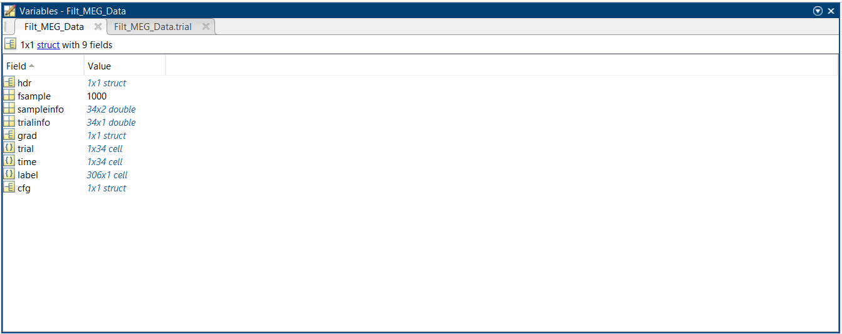

Subject 2: 59

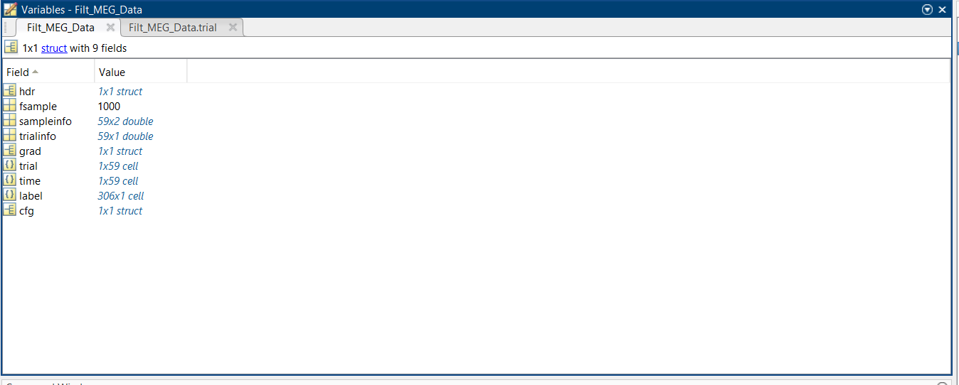

Subject 3: 26

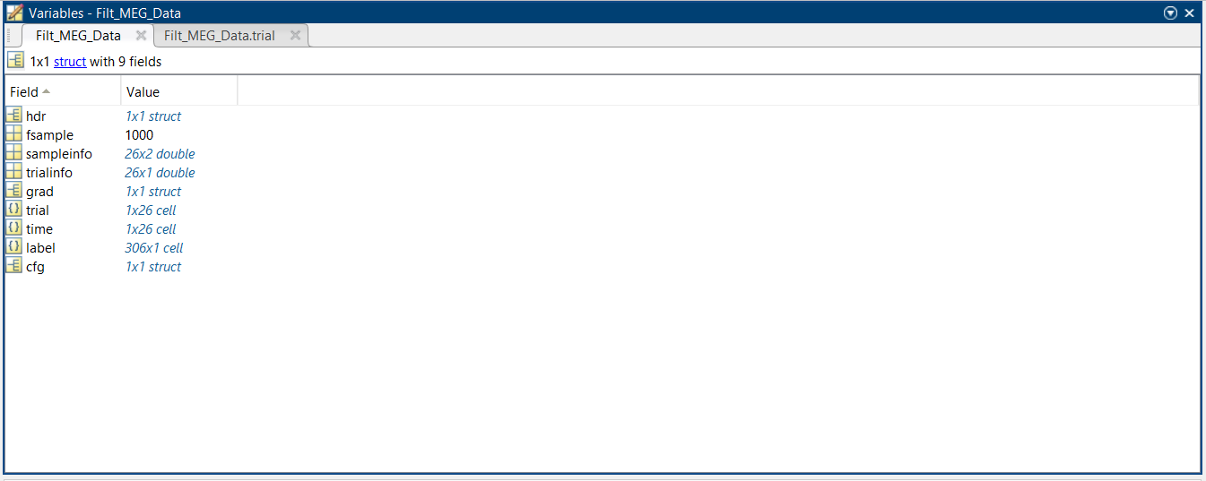

Subject 4: 34

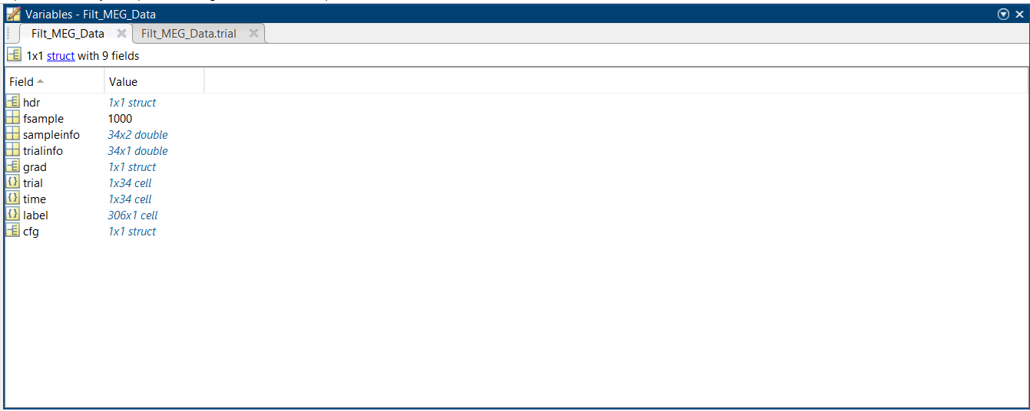

Subject 6: 35

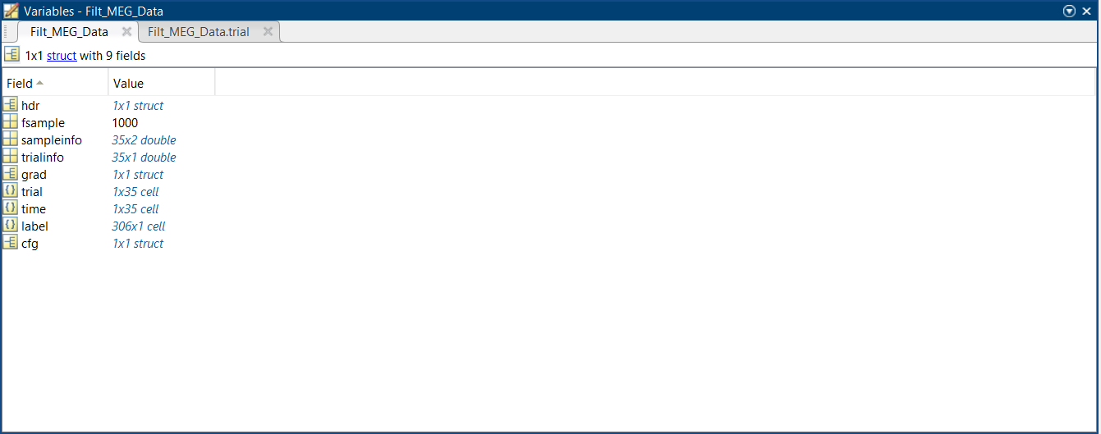

Subject 8: 31

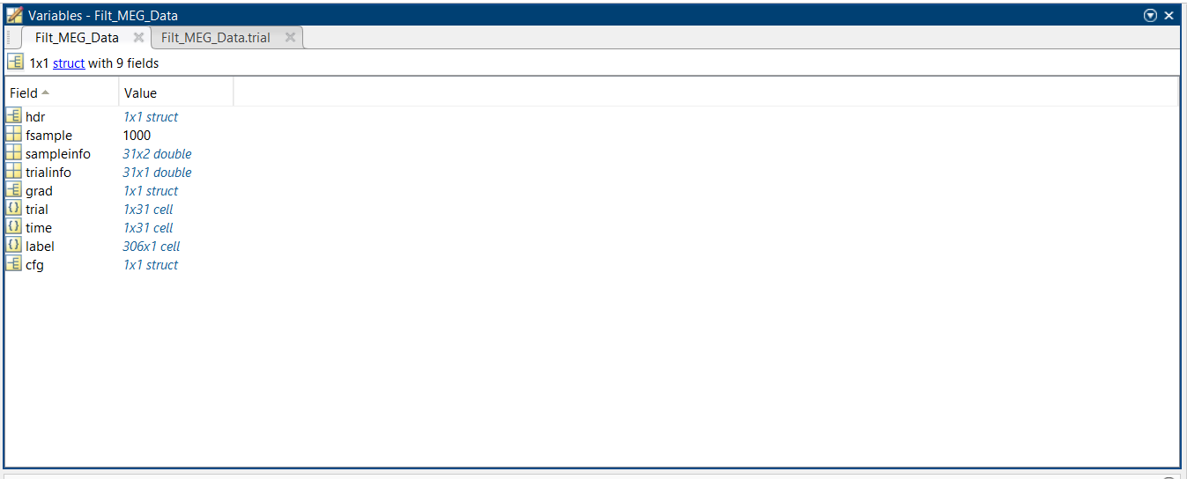

Subject 10: 30

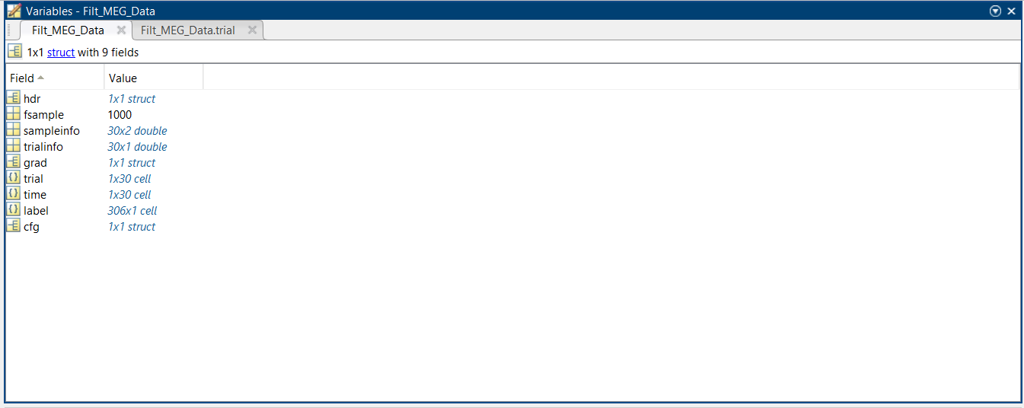

Subject 11: 21

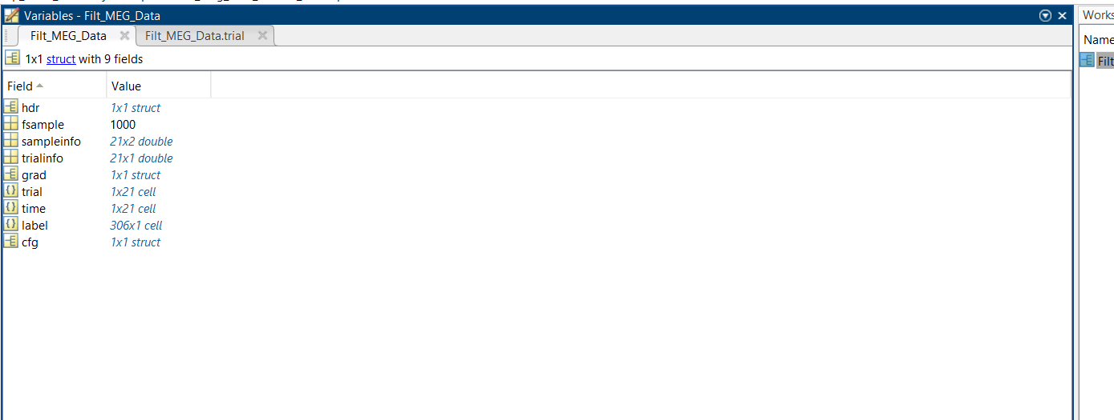

Subject 12: 40

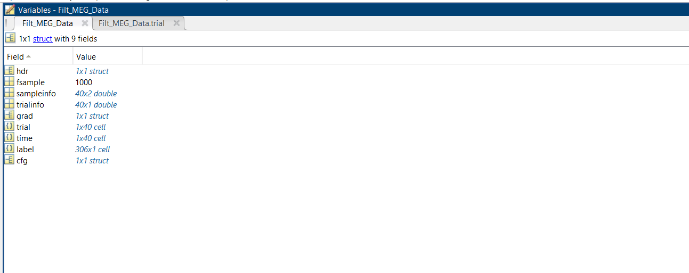

Subject 13: 40

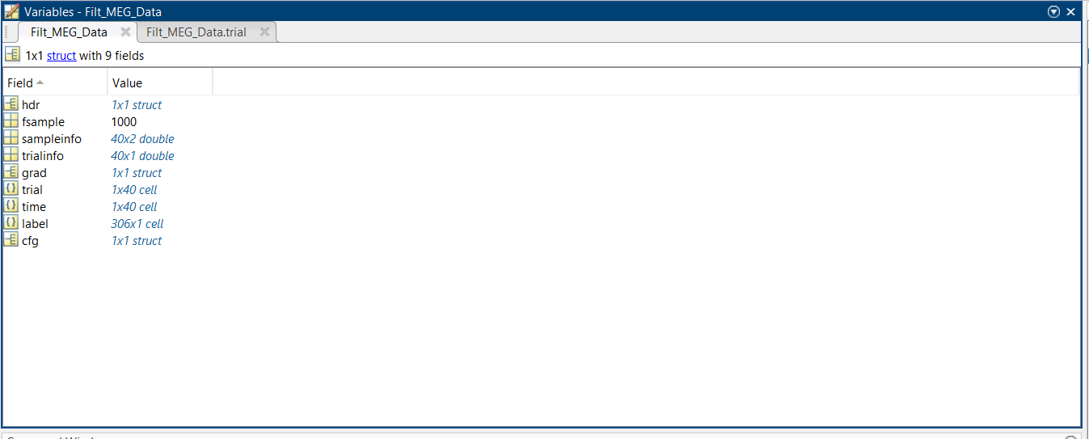

Subject 14: 34

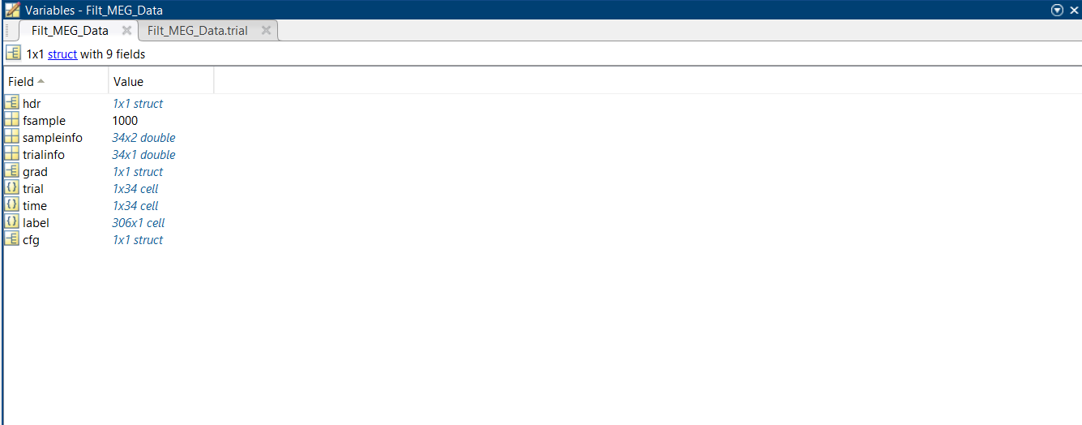

Subject 15: 30

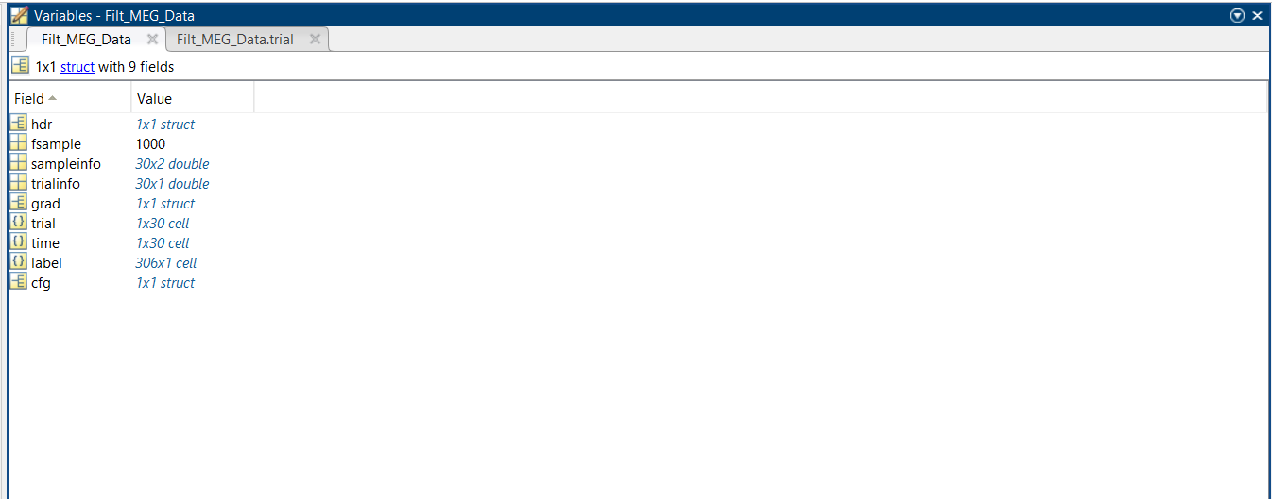

Subject 16: 31

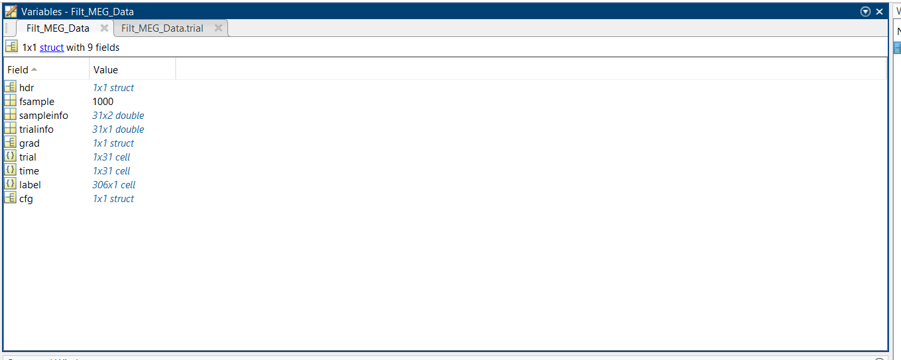

Subject 17: 28

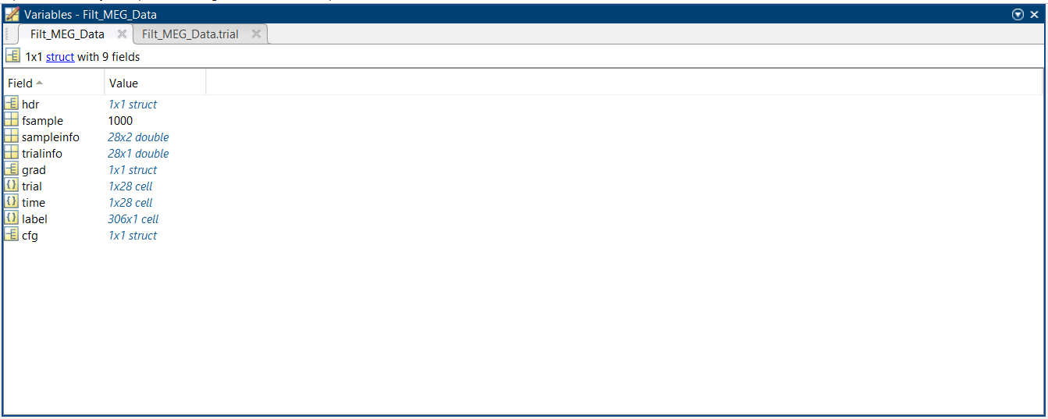

Subject 18: 36

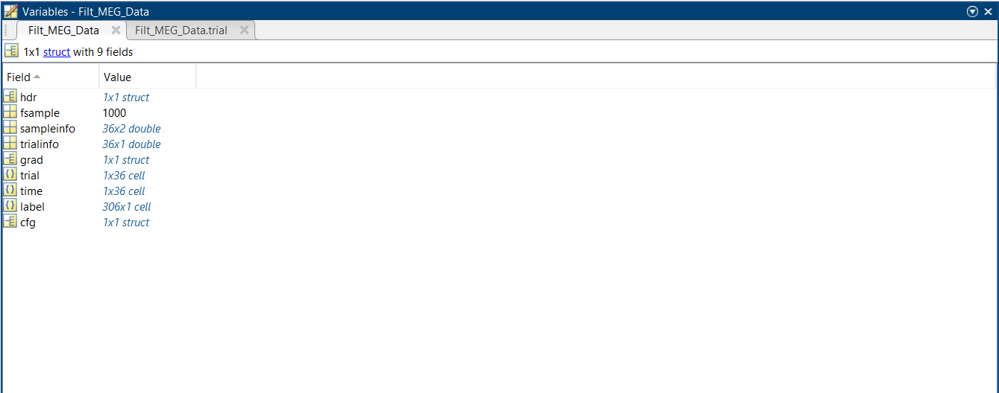

Subject 20: 39

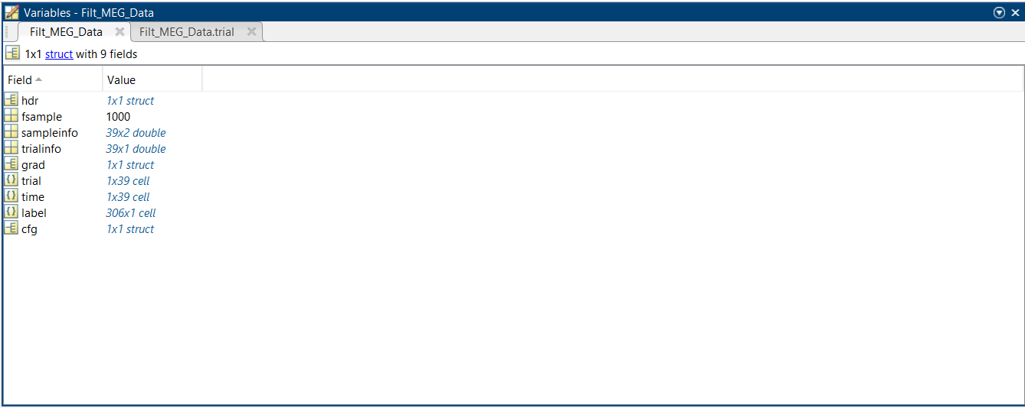

Total: 548 trials

Healthy rsec:

Subject1: 16

Subject 2: 16

Subject3: 16

Subject4: 16

Subject 6: 16

Subject 8: 16

Subject 10: 16

Subject 11: 16

Subject 12: 16

Subject 13: 16

Subject 14: 16

Subject 15: 16

Subject 16: 16

Subject 17: 16

Subject 18: 16

Subject 20: 16

Total: 256

Healthy rseo:

Subject 1: 16

Subject 2: 16

Subject 3: 16

Subject 4: 16

Subject 6: 16

Subject 8: 16

Subject 10: 16

Subject 11: 16

Subject 12: 16

Subject 13: 16

Subject 14: 16

Subject 15: 16

Subject 16: 16

Subject 17: 16

Subject 18: 16

Subject 20: 16

Total: 256 trials

Before preprocessing:

Mci 1st click: 206

Mci 2nd click: 194

Mci rsec: 64

Mci rseo: 79

Healthy 1st click: 525

Healthy 2nd click: 548

Healthy rsec: 256

Healthy rseo: 256

After preprocessing:

Mci 1st click: 206

Mci 2nd click: 194

Mci rsec: 64

Mci rseo: 79

Healthy 1st click: 525

Healthy 2nd click: 548

Healthy rsec: 256

Healthy rseo: 256